**Dharmsinh Desai University**



**Academic Year: 2023-24**

**Department: Institute of Management &**

**Information Science**

**Subject: Software Design and Testing**

# Topic: Virtual Event Management

**Name:**

**MA057 – Jaymin Valaki D. Submitted to Prof. Mianl Shah**

**ID No: 22MAPOG067 MCA Department**

**Professor Sign: Student Sign:**

Contents

Topic: Virtual Event Management 1

1. Introduction 3

2. Class Diagram 4

3. Object Diagram 4

4. Use case Diagram 5

5. Sequence Diagram 6

6. Collaboration Diagram 7

7. Activity Diagram 8

8. State chart Diagram 9

9. Test cases 10

# Introduction

A Virtual Event Manager is a comprehensive tool designed to plan, execute, and evaluate online events. It provides a platform for event organizers to manage all aspects of an event, from scheduling and ticketing to attendee engagement and post-event analysis.

The platform offers a range of features including customizable event pages, ticket sales management, real-time analytics, and interactive tools such as live chat and polling. It aims to streamline the event management process, making it easier for organizers to host successful virtual events.

With the rise of remote work and social distancing measures, Virtual Event Managers have become an essential tool in today’s digital world. They allow businesses, educational institutions, and other organizations to connect with their audience in a virtual environment, overcoming geographical barriers and making events more accessible.

# Class Diagram

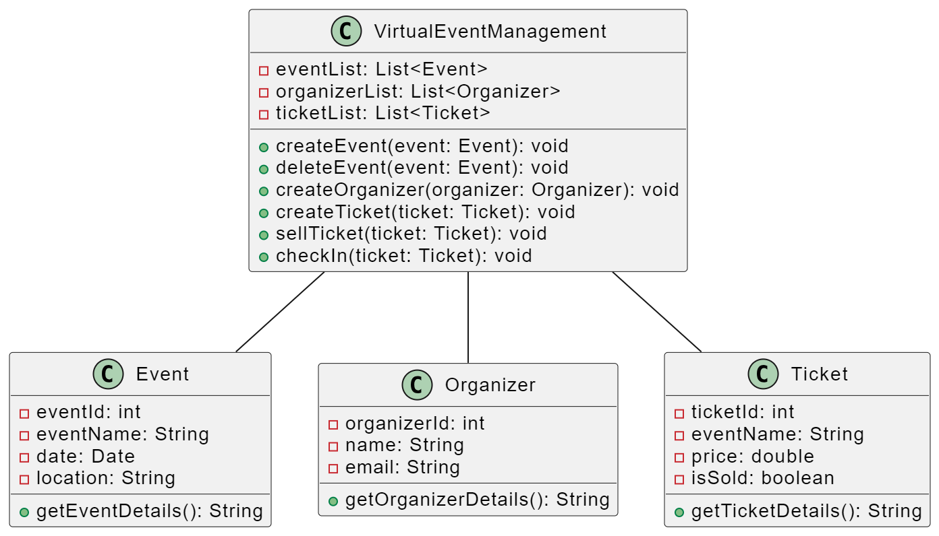

# Object Diagram

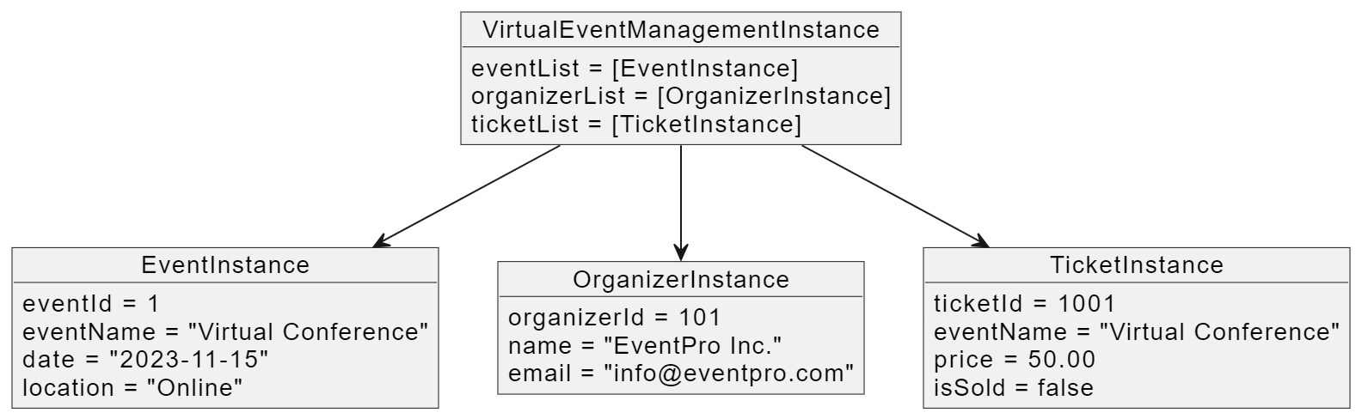

# Use case Diagram

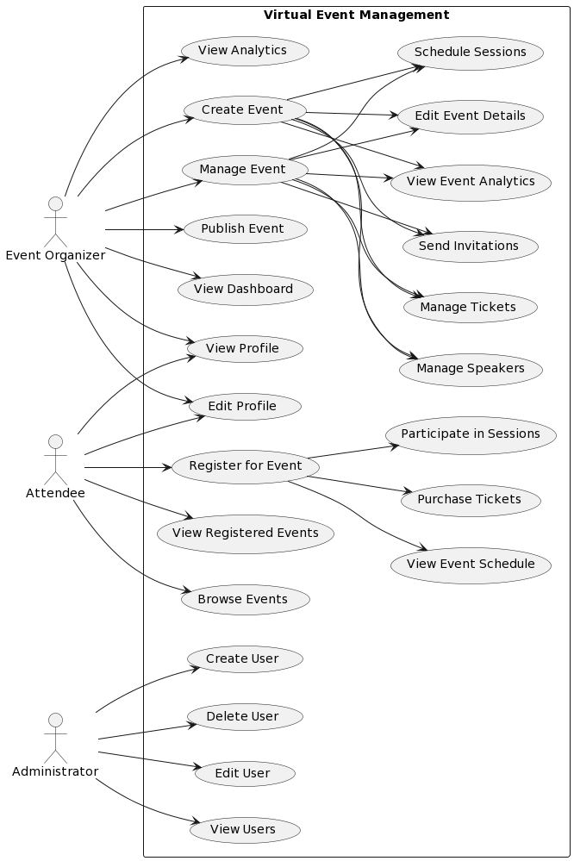

# Sequence Diagram

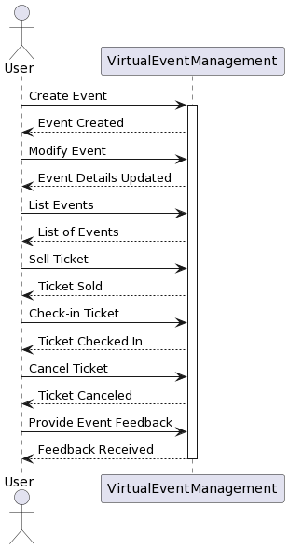

# Collaboration Diagram

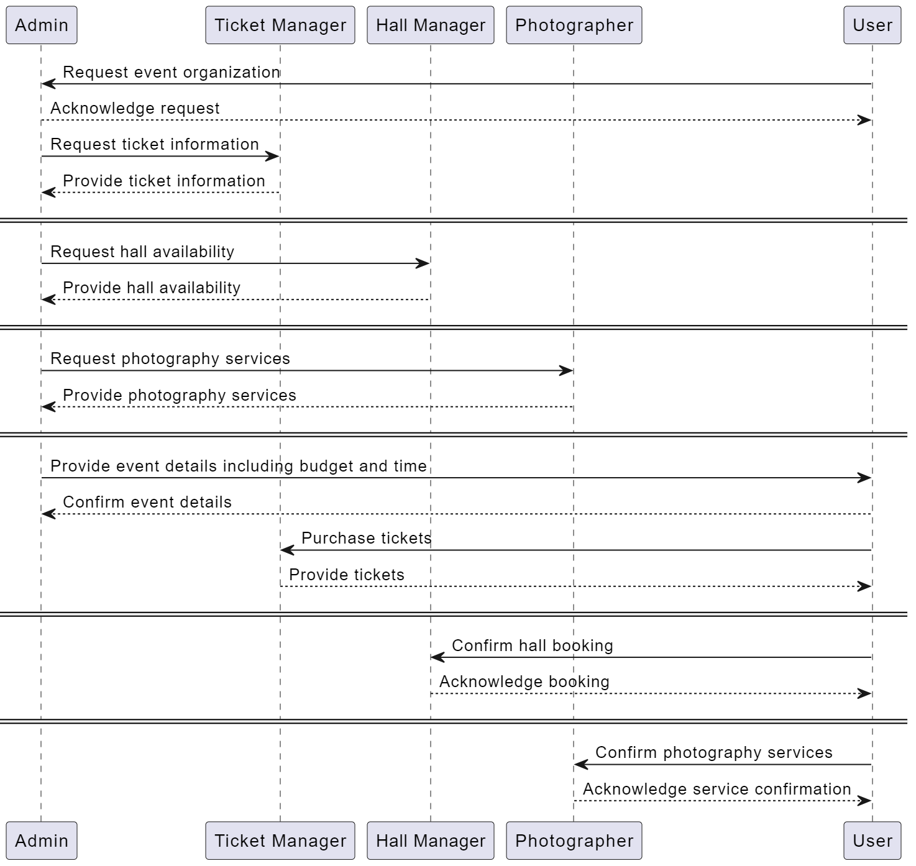

# Activity Diagram

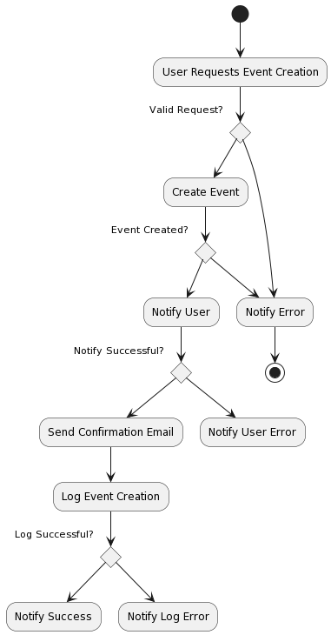

# State chart Diagram

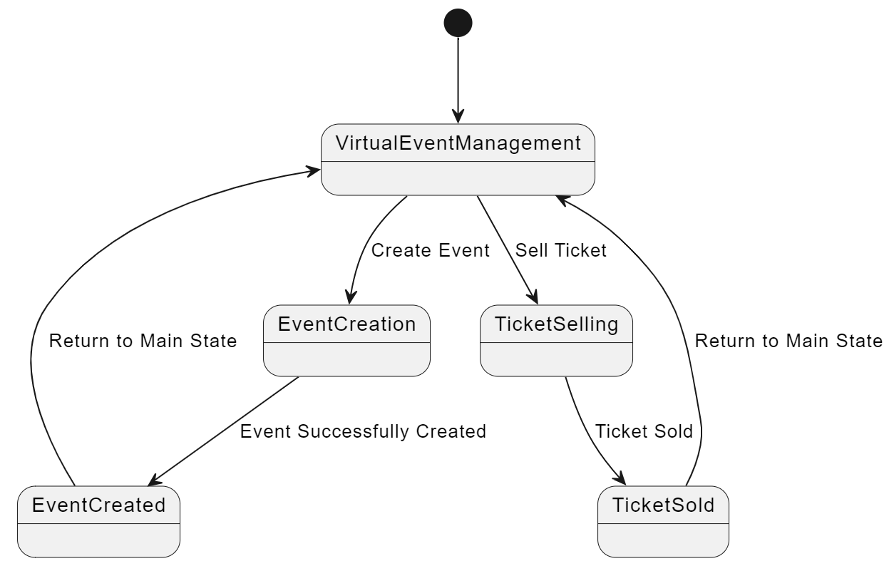

# Test cases

|  |  |  |  |
| --- | --- | --- | --- |
| **Feature** | **Description** | **Input** | **Expected Output** |
| User Registration | User creates an account with valid details | User details (name, email, password) | Account created, user can log in |
| User Login | Registered user logs into the system | Email, password | Successful login, access to user's dashboard |
| User Authentication | User enters invalid login credentials | Invalid email or password | Error message:  "Invalid credentials" |
| Event Creation | User creates a new event | Event details (name, date, location) | Event created and  listed in user's events |
| Event Editing | User updates event details | Updated event details (e.g., date) | Event details updated and displayed |
| Event Deletion | User deletes an event | Event ID | Event removed from the user's dashboard |
| Ticket Booking | User purchases a ticket for an event | Event ID, number of tickets | Tickets reserved, payment confirmation |
| Ticket Availability | User checks ticket availability for an event | Event ID, number of tickets needed | Number of available tickets for the event |
| Ticket Cancellation | User cancels a booked ticket | Ticket ID | Ticket canceled; refund processed |
| Event Listing | User views a list of all available events | None | List of events with details displayed |
| Activity Creation | User creates a new activity for an event | Activity details (name, date, time) | Activity created and associated with the event |
| Activity Editing | User updates activity details | Updated activity details (e.g., time) | Activity details updated and displayed |
| Activity Deletion | User deletes an activity | Activity ID | Activity removed from the event |